## **CHAUDHARY HAMDAN**

**1905387**

**OOP LAB-6**

**Date : 05-09-2020**

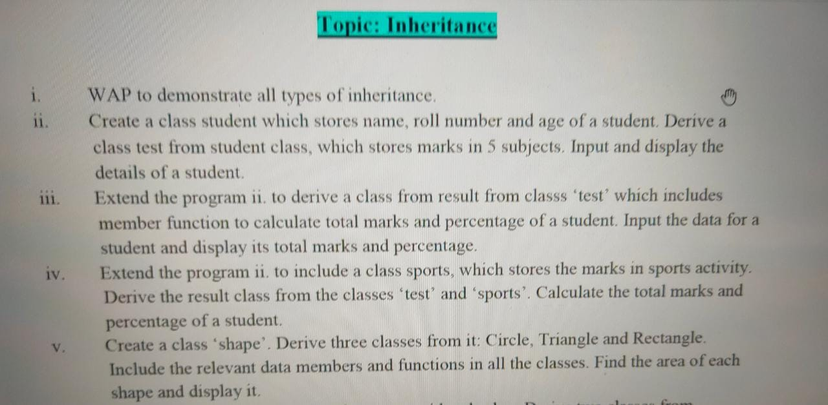

1.

#include<iostream>

using namespace std;

class A

{

protected:

int a;

public:

void dispa()

{

a=10;

cout << "Entered = " << a << endl;

}

};

class A1

{

protected:

int a1;

public:

void dispa1()

{

a1=21;

cout << "A1 Entered = " << a1 << endl;

}

};

class B : public A

{

protected:

int b;

public:

void dispb()

{

b=20;

cout << "B Entered = " << b << endl;

}

};

class C : public A

{

protected:

int c;

public:

void dispc()

{

c=30;

cout << "C Entered = " << c << endl;

}

};

class D : public B

{

protected:

int d;

public:

void dispd()

{

d=40;

cout << "D Entered = " << d << endl;

}

};

class E : public A, public A1

{

protected:

int e;

public:

void dispe()

{

e=50;

cout << "E Entered = " << e << endl;

}

};

class F : public B

{

protected:

int f;

public:

void dispf()

{

f=60;

cout << "D Entered = " << f << endl;

}

};

int main()

{

B obb;

C obc;

D obd;

E obe;

F obf;

cout << "Single : \n";

obb.dispa();

cout << "Multilevel : \n";

obd.dispa();

cout << "Hybrid : \n";

obd.dispa();

obf.dispa();

cout << "Multiple : \n";

obe.dispa();

obe.dispa1();

cout << "Hierarchical : \n";

obb.dispa();

obc.dispa();

}

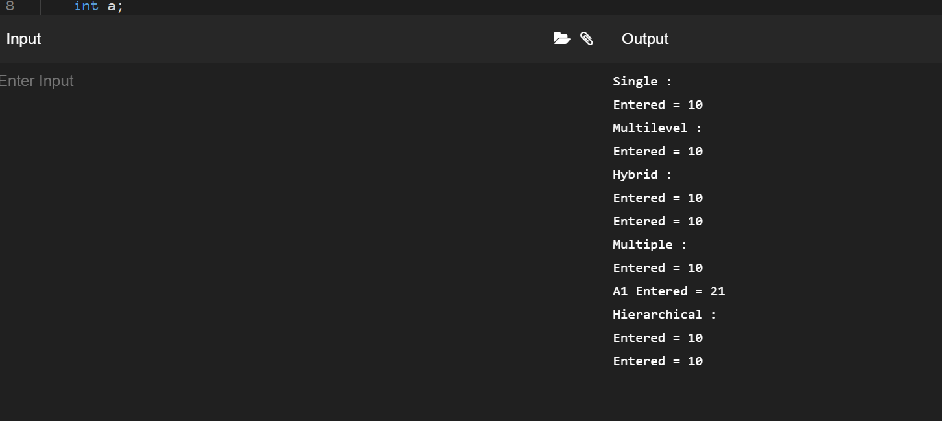

2.

#include<iostream>

using namespace std;

class student

{

protected:

char name[20];

int roll;

public:

void getdata()

{

cout << "Enter roll and name " << endl;

cin >> roll >> name;

}

};

class test : public student

{

protected:

int sub[5];

public:

void getmark()

{

cout << "Enter 5 subjects marks : " << endl;

cin >> sub[0] >> sub[1]>> sub[2]>> sub[3]>> sub[4];

}

void details()

{

cout << "\n\nName : " << name << " Roll number : " << roll << endl;

cout << "Marks in 5 subjects : " << sub[0] << ", " << sub[1] << ", " << sub[2] << ", " << sub[3] << ", " << sub[4] << endl;

}

};

int main()

{

test ob;

ob.getdata();

ob.getmark();

ob.details();

}

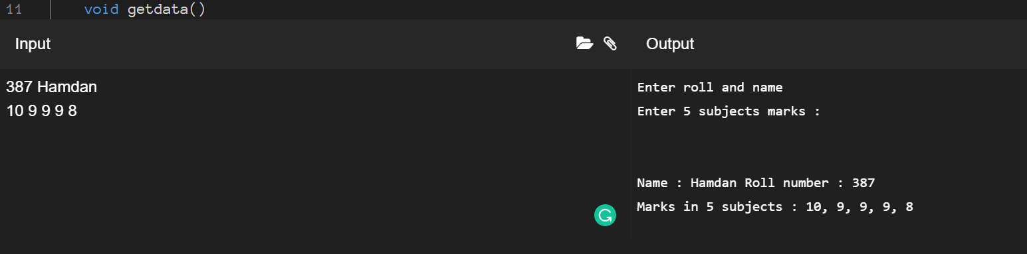

3.

#include<iostream>

using namespace std;

class student

{

protected:

char name[20];

int roll;

public:

void getdata()

{

cout << "Enter roll and name " << endl;

cin >> roll >> name;

}

};

class test : public student

{

protected:

int sub1;

int sub2;

int sub3;

int sub4;

int sub5;

public:

void getmark()

{

cout << "Enter 5 subjects marks : " << endl;

cin >> sub1 >> sub2>> sub3 >> sub4 >> sub5;

}

void details()

{

cout << "\n\nName : " << name << " Roll number : " << roll << endl;

cout << "Marks in 5 subjects : " << sub1 << ", " << sub2 << ", " << sub3 << ", " << sub4 << ", " << sub5 << endl;

}

};

class result : public test

{

int total;

float percent;

public:

void calc()

{

total = sub1+sub2+sub3+sub4+sub5;

percent = (total *100)/50;

}

void display()

{

cout << "Total Marks = " << total << "Percentage = " << percent << endl;

}

};

int main()

{

result ob1;

ob1.calc();

ob1.getdata();

ob1.getmark();

ob1.details();

ob1.calc();

ob1.display();

}

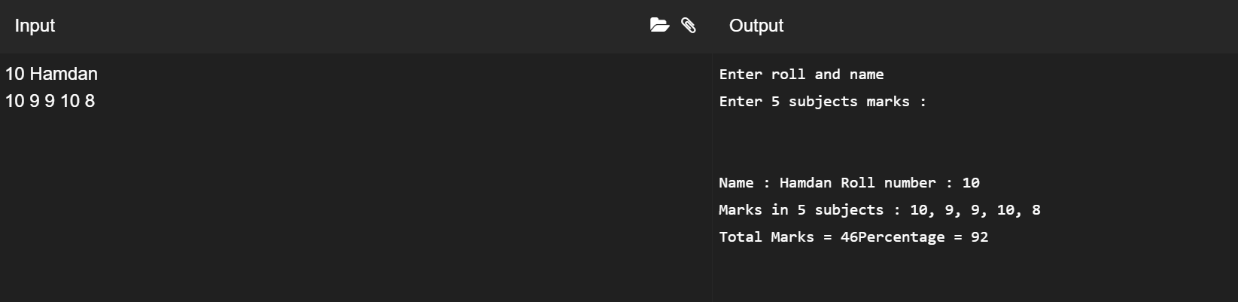

4.

#include<iostream>

using namespace std;

class student

{

protected:

char name[20];

int roll;

public:

void getdata()

{

cout << "Enter roll and name " << endl;

cin >> roll >> name;

}

};

class test : public student

{

protected:

int sub1;

int sub2;

int sub3;

int sub4;

int sub5;

public:

void getmark()

{

cout << "Enter 5 subjects marks : " << endl;

cin >> sub1 >> sub2>> sub3 >> sub4 >> sub5;

}

void details()

{

cout << "\n\nName : " << name << " Roll number : " << roll << endl;

cout << "Marks in 5 subjects : " << sub1 << ", " << sub2 << ", " << sub3 << ", " << sub4 << ", " << sub5 << endl;

}

};

class sports

{

protected:

int msports;

public:

void getspo()

{

cout << "Enter marks in sports : ";

cin >> msports;

}

};

class result : public sports, public test

{

int total;

float percent;

public:

void display()

{

cout << "Marks in sports = " << msports << endl;

total = sub1+sub2+sub3+sub4+sub5+msports;

percent = (total*100)/60;

cout << "Total marks : " << total << "Percent = " << percent << endl;

}

};

int main()

{

result ob1;

ob1.getdata();

ob1.getmark();

ob1.getspo();

ob1.display();

ob1.details();

ob1.display();

}

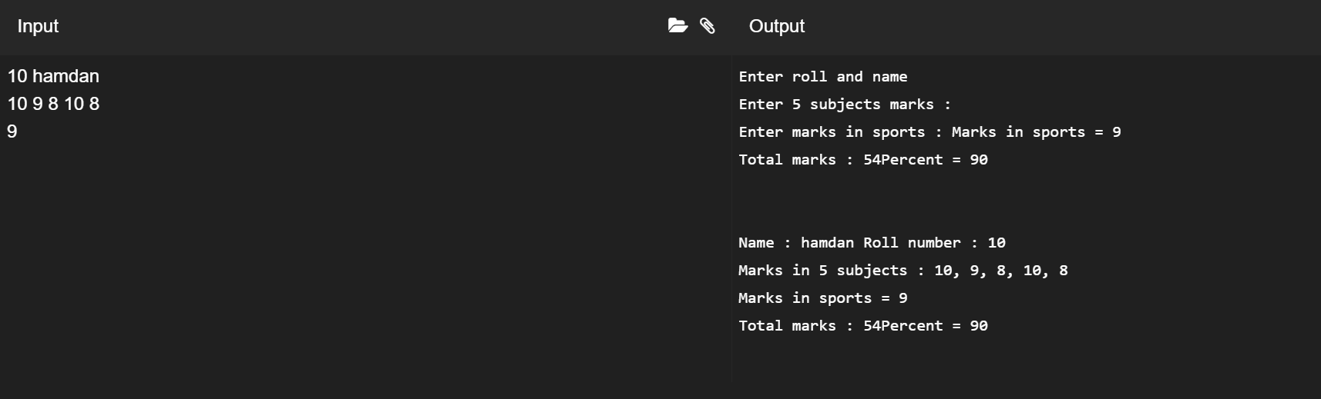

5.

#include<iostream>

using namespace std;

class shape

{

protected:

float areac;

float areat;

float arear;

};

class circle : public shape

{

public:

void carea()

{

int a=10;

areac = 3.14*a*a;

cout << "Circle : " << areac << endl;

}

};

class triangle : public shape

{

public:

void tarea()

{

int a=10;

int b=20;

areat = 0.5*a*b;

cout << "Triangle : " << areat << endl;

}

};

class rectangle : public shape

{

public:

void rarea()

{

int a=10;

int b=20;

arear = a*b;

cout << "Rectangle : " << arear << endl;

}

};

int main()

{

circle obc;

obc.carea();

triangle obt;

obt.tarea();

rectangle obr;

obr.rarea();

return 0;

}

